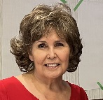
Report on the NCWC 130th AGM Patricia Leson, Past President
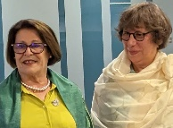
We gathered in unity and friendship at the Parktown Hotel in Saskatoon, Saskatchewan, from June 01 – 04. It was an honour to welcome our special guests from the International Council of Women, President Martine Marandal and Treasurer Ludovina Moriera. The Lieutenant Governor of Saskatchewan, the Honourable Russ Mirasty, and the Saskatchewan Minister for the Status of Women, Laura Ross, sent virtual messages of congratulations, support for our work, and a warm welcome to the province.
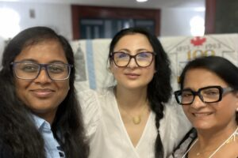
Our AGM included reports from all our Vice Presidents and Convenors along with several from our Federates. The resolutions that were presented from our grassroots councils were well researched, carefully analyzed, and passionately discussed before each was voted on. Those that were accepted as policies are now listed on our website.
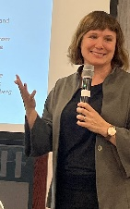
The conference portion of our event included a very interesting housing forum led by Dr. Brenda Mishak, a professor at the Universities of Saskatchewan and Victoria. We were actively involved and engaged in a national survey which enabled us to review best practices for meeting the ever-mounting concerns of the lack of adequate housing and the multi faceted issues of homelessness. This piqued the interest of the delegates to the extent that we chose the topic of “Housing is a Human Right” as the Common Program for the next two years.
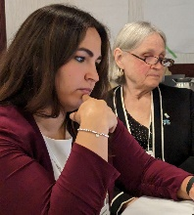
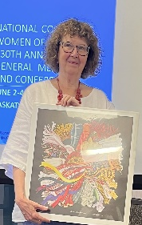
The education portion of our conference focussed on the ongoing work involved in dealing with the recommendations of inquiry into Missing and Murdered Indigenous Women and Girls. The session began with a very touching person life story from a survivor, Myrna LaPlante. Her presentation was a perfect introduction to our next speaker, Jennifer Moore-Rattray, the Federal Ministerial Representative. She brought us up to date on her work in providing recommendations on the implementation of the recommendation of the MMIWG Commission to create an Indigenous and Human Rights Ombudsman. This was followed by an interactive discussion with a panel comprised of members of the Prince Albert Police Service Women’s Commission, a group dedicated to the eradication of the horrific assaults on Indigenous women and girls. We then boarded the bus to Wanuskewin Heritage Park, a sacred place and gathering site for the past 6400 years that is dedicated to advancing the understanding and appreciation of the evolving culture of the Northern Plains Indigenous peoples.
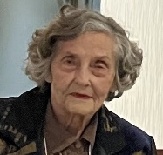
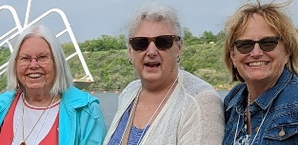
While we dedicated our time to the myriad of issues at hand, we still took time to socialize and enjoy the pleasures of meeting in person once again. The ‘memories table’ featured articles and photos from our past 130 years – we do, indeed, stand on the shoulders of giants! The dinner cruise on the South Saskatchewan River, hosted by LCW Saskatoon, was delightful! Our banquet was delicious, and our guest speaker from the Canadian Light Source, Robert Blythe, was very knowledgeable and extremely entertaining.
Our 130th AGM and Conference concluded with a sincere thank you to the outgoing leadership team and the induction of the President, Vice-Presidents, and Convenors for 2023 – 2025. It was, indeed, a celebration of our past and yet it was firmly focussed on the present and created a blueprint for a very bright future for the National Council of Women of Canada!

